Ideation Phase
Empathize & Discover

Date | 30 September 2026
Team ID | SWTID-2026-7693
Project Name | AI - FAQ ASSISTANT
Maximum Marks | 4 Marks

Empathy Map Canvas:
Empathy Map Canvas helps the team understand the needs, thoughts, feelings, behaviours, and challenges of users. For a food ordering and delivery application, the map focuses on what users think and feel, see, hear, say and do, along with their pain points and goals. Users usually expect fresh food, affordable prices, quick delivery, easy ordering, and reliable customer support. Common challenges include delivery delays, high charges, incorrect orders, and limited healthy food options. By understanding these user experiences, the team can identify important problems and design a user-friendly solution that provides a convenient, reliable, and satisfying food ordering experience.

Example:
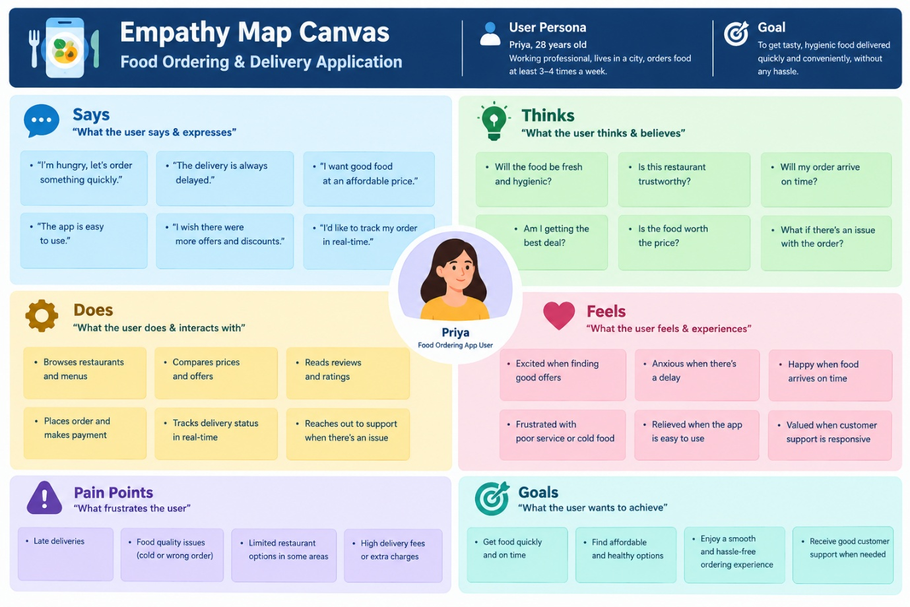

Example: Food Ordering & Delivery Application
